Risk Assessment Report

- Go to Enrollment
- Reports
- Scroll down to Visits
- 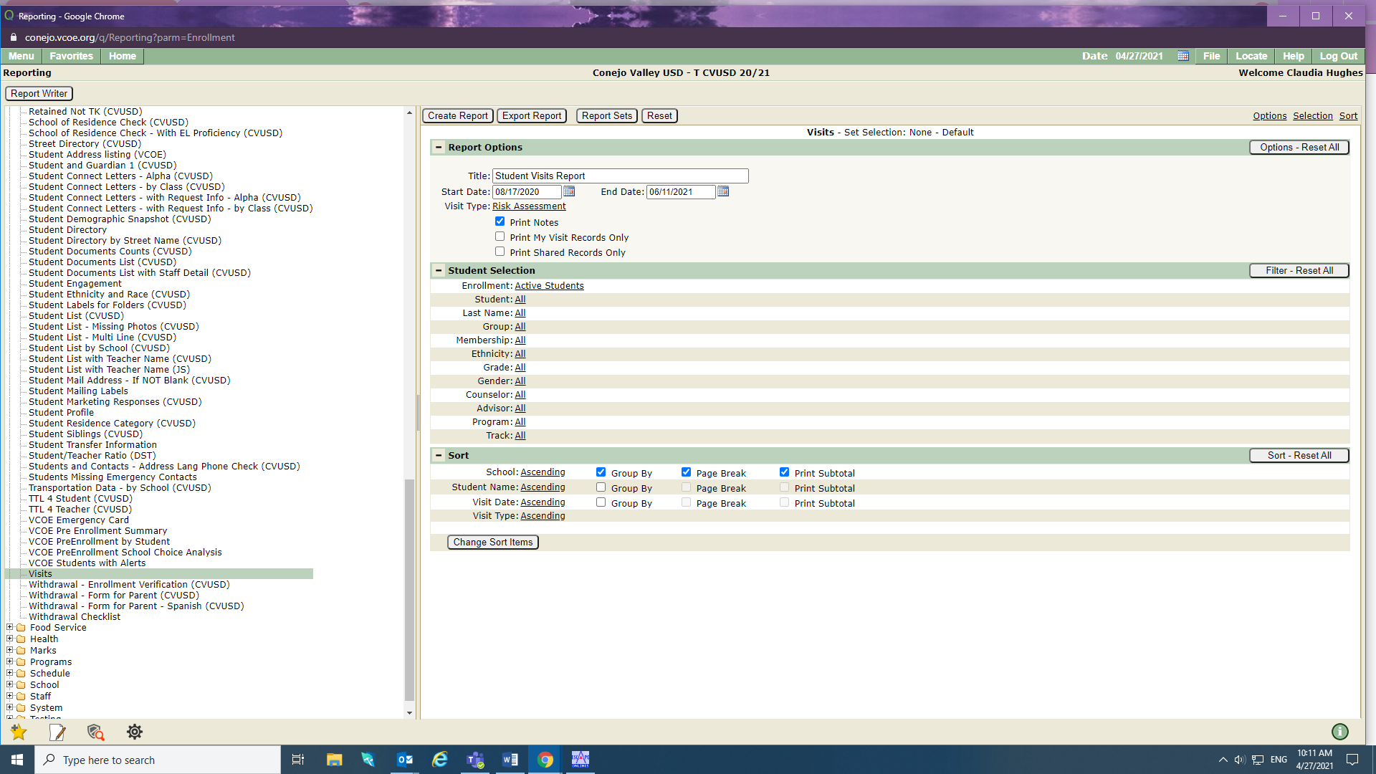
- Go to Visit Type and click ALL. You will get a drop down menu.
- Go all the way down until you see Risk Assessments
- Be certain to unclick Print Notes (unless you want the notes)
- Be certain Start Date and End Date are where you want them to be. And to generate a report for ALL the schools, leave Enrollment at Active Students.
- Under Sort click Print Subtotal in order to get a total per school.

